1. Metoda wykrywa proste relacje będące złączeniem wykrytych encji ze względu na grupowanie relacji.
2. Dwie metody: **EType** oraz **EType+**

**Etype** wykorzystuje sieć FFN otrzymującą na wejściu dwie encje generując prawdopodobieństwo relacji [supervised]. one-layer feed-forward network, entity type combinations as input, r = FFN(tehead -tetail ),

where tehead -tetail is the one hot vector of the entity

type pair

1. **GPU -** https://github.com/ttthy/ure
2. EType+:
   1. a relation classifier and a link pre-dictor
   2. March
      1. The relation classifier, which is discriminative, takes entity types and several linguistic features (e.g., dependencies) as input to predict the relation r
      2. The link predictor then uses the (soft) predicted relation r to predict the missing entity in a specific position {head, tail} to produce more relations [semi-supervised]
      3. They thus used entropy over all relations as a regulariser. The maximisation of the entropy regulariser ensures the uniform relation distribution and allows more relations to be predicted.
   3. Simon
      1. firstly, its relation classifier employs a piece-wise convolutional network (PCNN) using only surface form without requiring hand-crafted features
      2. secondly, they replaced entropy with two regularisers: Ls (skewness), to encourage the relation classifier to be confident in its prediction, and Ld (dispersion), to ensure several relation types are predicted over a minibatch. Note that, Ls is equivalent to the negation of the entropy used in March.
   4. Wykorzystuje **link predictor** z March oraz regularyzatory z Simona
3. Wyniki

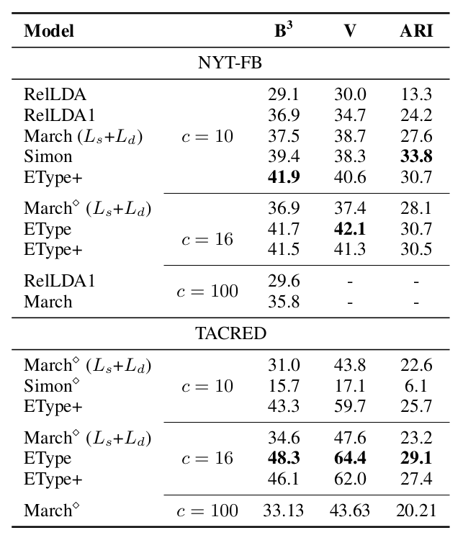

1. Metryki
   1. B3 - harmonic mean of precision and recall for clustering task
   2. V-measure is analysed in terms of homogeneity and completeness
   3. ARI measures the similarity between two clusterings
      1. shown to be used when there are large equal- sized clusters (Romano et al., 2016) while relation datasets are generally imbalanced
      2. Due to this ARI might not be appropriate to evaluate URE

